**SOFEIR 2018**

**Université de Bourgogne Franche-Comté**

**15-16 March 2018**

**FROM IRISH LAND TO IRISH SOIL:**

**MATERIALITY AND METAPHORS**

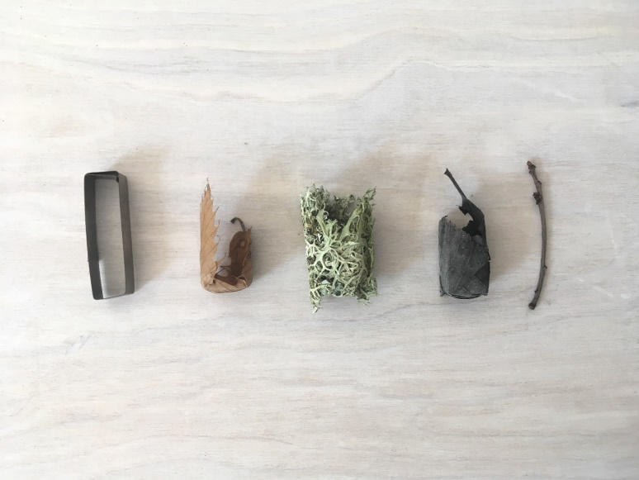

Stuart Cairns, “All That Sits Unsaid, Material Poetics”, 2017 © Stuart Cairns

<https://stuartcairns.com/>

**Maison des Sciences de l’Homme de Dijon**

**Amphithéâtre / Salles R02-R03**

**JEUDI 15 MARS / THURSDAY, MARCH 15th**

**9h30 –** Accueil – Ouverture / Opening of the conference

**AMPHITHEATRE DE LA MSH**

**10h-10h45** **Marion Naugrette** (Université Paris 3) – **Maryvonne Boisseau** (Université de Strasbourg), *« Remember life on Earth! », Horizons géopoétiques dans l’œuvre de Derek Mahon*

**10h45-11h15** **Britta Olinder** (Université de Gothenburg, Göteborg, Sweden), *The Irish Geopoetics of Vona Groarke’s Work*

**11h15 – Café / Coffee Break**

**11h45-12h45 (**Keynote lecture) **Eamon Maher** (Institute of Technology, Tallaght), *Preserving a strong sense of place: Terroir in the Work of John McGahern and Dermot Healy*

**13h-14h – Lunch / Buffet**

**ATELIER 1 (Amphi)**

**14h-14h30 Eva Urban** (Queen’s University Belfast), *Fractured Liminality in Kabosh’s Green and Blue and Lives in Translation*

**14h30-15h Martine Pelletier** (Université François Rabelais, Tours), *Brian Friel's Plays, Peasant and Unpeasant*

**15h-15h30 Marine Galiné** (Université de Reims Champagne-Ardenne), *“[…] the cry of a woman keening. It came from the bog”: (Re)presentations of the Bog in Nineteenth-Century Irish Gothic Fiction*

Questions

**ATELIER 2 (Salle R02)**

**14h-14h30 Medhi Ghassemi** (Université Lille 3), *Writing, Land, Sea and Sand: The Littoral in John Banville’s The Sea*

**14h30-15h Fiona McCann** (Université Lille 3), *Still “fork-tongued on the border bit”?: Writing (about) the Irish Border 1987-2017*

**15h-15h30 Marie Mianowski** (Université de Grenoble Alpes), *From Land to Soil: Walking Ireland’s Border in Garrett Carr’s The Rule of the Land (2017)*

Questions

**15h45-16h – Café / Coffee break**

**16h-17h** (Guest speaker) **Jean-Pierre Garcia** (Université de Bourgogne), *Construction et remotivation des terroirs et des climats sur le temps long (en Bourgogne)*

**17h45–18h30 – Musée Magnin**

4 rue des Bons Enfants

Exposition « Exquises Esquisses »

**19h30 – Dégustation et Dîner**

Caveau « Le Trou, L’Hôtel de Saulx » 15 rue Vannerie (Dijon)

(<http://letroudijon.fr/accueil/>

**VENDREDI 16 MARS / FRIDAY, MARCH 16th**

**AMPHITHEATRE DE LA MSH**

**9h-10h Assemblée Générale de la SOFEIR**

**10h-10h30 – Café / Coffee Break**

**10h30-11h Lisa FitzGerald** (Université Rennes 2), *Material Bodies: Three Performance-Based Interventions in the Irish Landscape*

**11h-11h30** **Anne Goarzin** (Université Rennes 2), *Matters of concern: Irish Artists and the Arctic*

**11h30-12h** **Shannon Wells-Lassagne** (Université de Bourgogne), *The Picturesque and the Grotesque: The Importance of Setting in Moone Boy and Father Ted*

Questions

**12h30-13h30 – Buffet/ Lunch**

**13h30-14h30** (Invited artist) **Stuart Cairns**

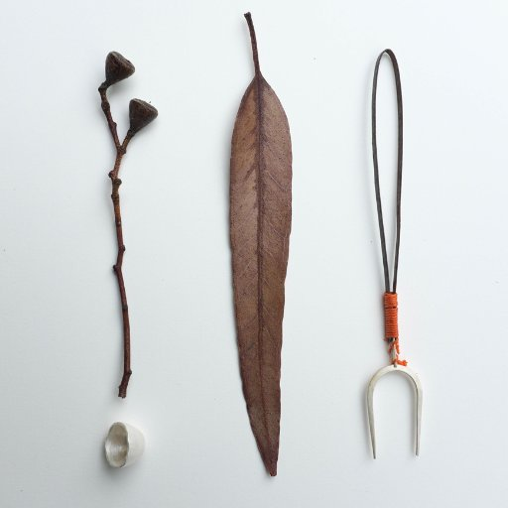

**ATELIER 1 (Amphi)**

**15h-15h30 Dorothy Cashman** (Dublin Institute of Technology), *‘For two young bullocks sold at Bective’: The topographies of a Franciscan friary in 1798*

**15h30-16h Anne-Catherine de Bouvier** (Université de Caen Normandie), *Between the living and the afterlife: aspects of burying in Ireland*

**16h-16h30 Chloé Lacoste** (Université Paris Sorbonne), *“I brought him here to all Ireland”: From Glasnevin to the Irish Diaspora: The Reapropriation of Land through the Graves of the Fenian Dead*

Questions

**ATELIER 2 (Salle R03)**

**15h-15h30 William H. Mulligan Jr.** (Murray State University, USA), *Landscape, Migration, and Occupation:* *Migration of Irish Miners from the Beara Peninsula to the Michigan Copper District*

**15h30-16h Tim Heron** (Université de Reims Champagne-Ardenne), *‘Wasteland Life’: Punk Use of the Urban Landscape in ‘Troubles’-era Belfast*

Questions

**16h45 – Clôture du Congrès**

**Apéritif de Clôture du Congrès au « Flannery’s Irish Pub »** 4 Place Saint-Bénigne (Dijon)  
(a 5 mn walk from the train station).

