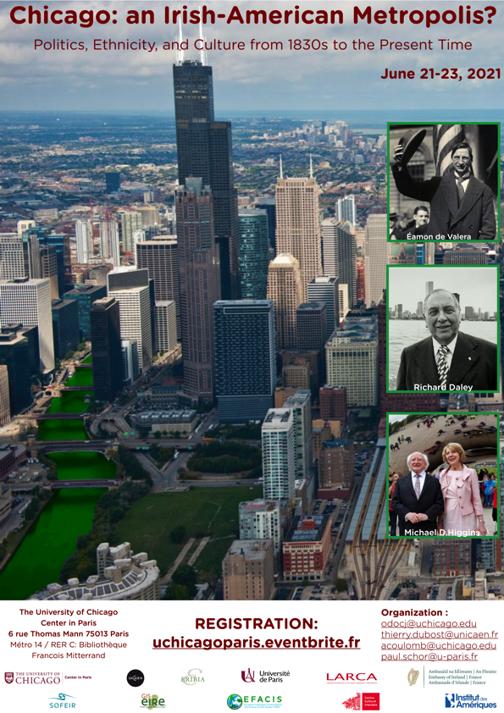
Tentative Program

Monday June 21, 2021
The University of Chicago Center in Paris
(Conference Room)

8:30 - 9:00 am: Registration and Coffee

9:00 - 9:15 am: Welcome Remarks
Keynote speech

“TBA”, David Brundage (University of California at Santa Cruz)

10:00 - 10:15 am: Q&A

10:15 - 10:30 am: Coffee Break

Session 1: Chicago and Transatlantic Irish Nationalism 10:30 - 11:30 am
Chair: James Chandler (University of Chicago)

Frank Rynne, Université de Cergy-Pontoise:
“Virtual Republic: The First National Convention of Fenian Brotherhood, Chicago, November 1863”
Gillian O’Brien, Liverpool John Moores University:
“A Carnival of Plots’ Irish-American Republicanism in the late Nineteeth-Century”
Andrew Wilson, Loyola University Chicago:
“From the South Side to the Bogside: Chicago and the Northern Ireland Conflict”

Lunch Break 12:00 - 13:45 pm

2:00 – 6:30 pm

Session 2: Chicago’s World Fairs and Transatlantic Irish Nationalism 2:00 - 3:20 pm
Chair: Claire Connolly (University College Cork)

Jeffrey O’Leary, Mitchell College:
“The Chicago World’s Fair 1893: The Windy City Braces for More Blarney”
Amy Mulligan, University of Notre Dame:
“Moving into Chicago’s “White City” – Race, Medieval Iconography and the Construction of Irishness at the 1893 World’s Fair”
Billy Shortall, Trinity College Dublin:
“No Thatched Cottages: The Chicago World’s Fair 1933”
Eimar O’Connor, Tyrone Guthrie Centre at Annaghmakerrig:
“Ireland and the Chicago World’s Fair: Castellated Kitsh or Crucial Controversy?”
3:40 - 4:00 pm: Coffee Break
Session 3: Irish Chicago Politics 4:00 - 5:00 pm
Chair: Henri Peretz (Université Paris 8 Vincennes Saint Denis)

Greg Koos, Executive Director Emeritus of the McLean County Museum of History:
““Whiskey Vs. Lager Beer – Bejabers”: The Irish and the Politics of Chicago’s Hinterland 1854-1860”
Ana Artiaga, Université de Toulouse-Jean Jaurès:
“The Chicago Irish and the Democratic Machine”
Richard Anderson, Rutgers University:
“How Chicago’s Irish Remade American Liberalism: Machine Politics and Class Identity in the Windy City”

5:20 - 5:30 pm: Coffee Break

Keynote Speech

“TBA”, Clair Wills, University of Cambridge
6:15 - 6:30 pm: Q&A

Tuesday June 22, 2021
Université de Paris, Amphithéâtre Buffon

8:30 - 9:00 am: Coffee
9:00 am - 12:00 pm

Keynote Speech

“TBA”, James Barrett, University of Illinois at Urbana Champaign

9:45 - 10:00 am: Q&A

10:00 - 10:20 am: Coffee Break

Session 4: Education, Work and Ethnic Identity in Irish Chicago 10:20 - 11:40 am
Chair: Paul Schor (Université de Paris)

Sophie Cooper, University of Leicester:
“Sister, sister: Irish Female Teachers and Ethnic Identity in Chicago, 1840-1922”
Catherine Healy, Trinity College Dublin:
““The Problem of Bridget”: Managing Irish Domestic Servants in Gilded Age Chicago”
Bradford Hunt, Loyola University Chicago:
“Irish-Americans and the 1919 Chicago Race Riot”
Maureen Curtin, Suny-Oswego:
"How to Locate Jack Conroy on a Chicago Map: at the Corner of Labor and Church, Riding the Rails of the Illinois Writers' Project"

Lunch Break 12:00 - 13:45 pm

2:00 - 6:30 pm

Session 5: Chicago and the Gaelic Revival 2:00 - 3:00 pm
Chair: Cliona Ni Riordain (Université Sorbonne Nouvelle)

Cuan Ó Seireadáin, The Gaelic League - Brian Ó Conchubhair, University of Notre Dame:
“The Irish-Language in Chicago: Forgotten Features of Ethnic Identity?”
Máire Nic an Bhaird, Maynooth University:
“Douglas Hyde: An Irish Idol in Chicago”
Liam Mac Mathúna, University College Dublin:
“Chicago and the Mid-West Leg of Douglas Hyde’s American Journey, 1906”

3:40 - 4:00 pm: Coffee Break

Session 6: Chicago and Irish Culture 4:00 - 5:00 pm
Chair: Fiona Kearnay (University College Cork)

Scott Spencer, Thorton School of Music, University of Southern California:
“Chicago at the Center of the Irish Piping World: Captain Francis O’Neill and the Edison Wax Cylinder Recorder”
Mary Rose O’Shea, University of Illinois at Chicago - Conor O’Shea, University of Illinois at Urbana-Champaign - Michael O’Shea, University of Toronto:
“No longer at the Crossroads: Irish Dance Halls in Chicago and Late Generation Ethnicity”

5:20 - 5:30 pm: Coffee Break

Keynote Speech

“TBA”, Aileen Dillane, University of Limerick

6:15 - 6:30 pm: Q&A

Wednesday June 23, 2021
Centre Culturel Irlandais

8:30 - 9:00 am: Registration and Coffee

9:00 am – 12:00 pm

Session 7: Questionnig Traditional Representations of Irish Chicago 9:00 – 10:20 am
Chair: Thierry Dubost (Université Caen Normandie)

Charles Fanning, Southern Illinois University
“Banish the Boushwah: Why We Ought to Read James T. Farrell”
Sean Farrell, Northern Illinois University:
“Writing a New History of the Irish in Illinois”
Shiben Banerji, School of the Art Institute of Chicago:
“Irish Home Rule: A Text in Motion”
Henri Peretz, Université Paris Vincennes-Saint-Denis:
“Mapping the Irish Territory in Chicago during the Great Migration, 1895-1940”

10:20 - 10:40 am: Coffee Break

Session 8: Diasporic Circulations 10:40 - 12:00 pm
Chair: Fiona McCann (Université de Lille)

Amélie Dochy, Université de Toulouse - Jean Jaurès:
“Illustrating Pleasant Irish Archetypes in Paintings: Erskine Nicol’s Images of Irish Life Presented in Chicago at the End of the Nineteenth Century”
Emma Moreton, University of Liverpool:
“Irish Emigrants Letters”
Patrick O’Sullivan, London Metropolitan University:
“Chicago, Theory and the Discourse of the Irish Emigrant Letter”

Lunch Break 12:00 - 13:45 pm

2:00 pm - 5:00 pm

Panel Discussion 1: the Irish Diaspora and Globalization
Moderators: Anne Groutel (Université Paris 1 Panthéon Sorbonne) - Grainne O’Keefe (Université Rennes 2)

Participants:
1
2
3
4

Panel Discussion 2: Chicago and Irish Culture
Moderator: Sylvie Mikowski (Université de Reims)

Participants:
1
2
3
4

This international and multidisciplinary conference is a partnership between the universities of Chicago, Caen Normandie and Paris

Logos of the three Universities

with the support of:

Logos of Research Centers and Institutions

